BACKGROUND MATERIAL

Bauer, T., & Erdogan, B. (2012) Chapter 6.1: Motivating employees through job design. Introduction to Organizational Behavior. Flatworld Knowledge. http://2012books.lardbucket.org/books/an-introduction-to-organizational-behavior-v1.0/s10-01-motivating-employees-through-j.html
Griffin, R. (2007). Chapter 6: Organization structure and design. Principles of Management. Houghton Mifflin, New York. http://college.cengage.com/business/griffin/sas_principles/1e/assets/students/know_bank/griffin_sas_KB_6.1.pdf
Now that you have read up on traditional approaches to job design, read up on job crafting. This reading is by Amy Wrzesniewski, who you saw in one of the videos above:
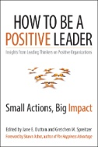

Wrzesniewski, A. (2014). Chapter 6: Engage in job crafting. In Dutton, J. E., & Spreitzer, G. M. (eds). How to Be a Positive Leader: Small Actions, Big Impact. San Francisco, CA, USA: Berrett-Koehler Publishers. [EBSCO eBook Collection]

Finally, this chapter provides a solid overview of job crafting including some relational, cognitive, and task crafting:
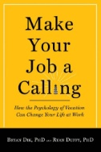

Dik, B. J., & Duffy, R. D. (2012). Chapter 7: Job crafting. Make Your Job a Calling: How the Psychology of Vocation Can Change Your Life at Work. West Conshohocken, PA: Templeton Press. [EBSCO eBook Collection]

